1. EXPERIMENT -13
2. 13.Demonstrate Infrastructure as a Service (IaaS) by creating a Virtual Machine using a Public Cloud Service Provider (Azure), configure with required memory and CPU.
3. 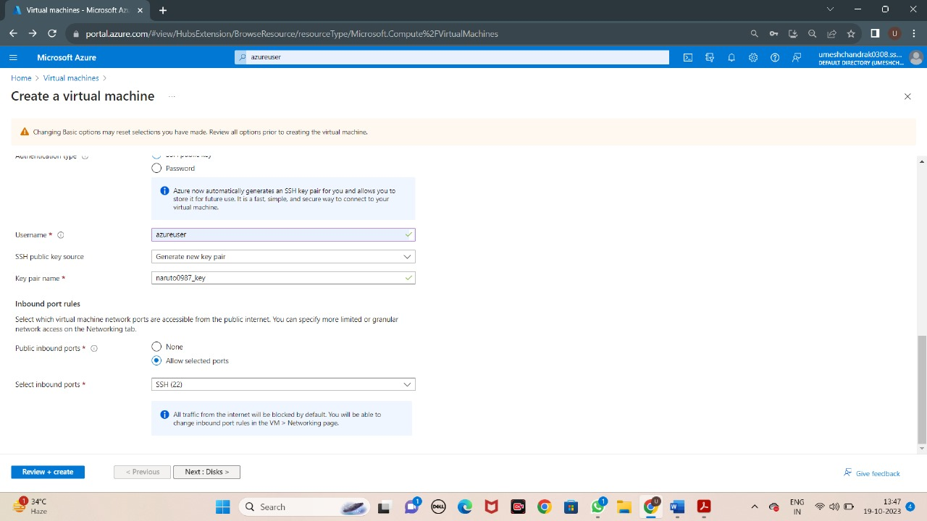

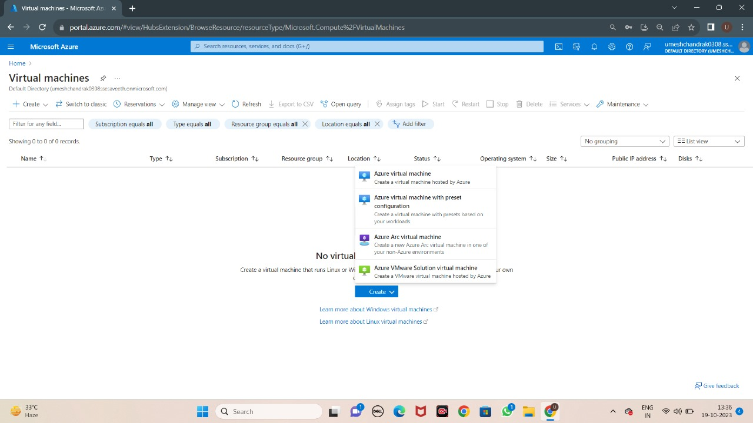

1. Adithya -192210283